# **Name: Abdurrahman Qureshi**

# **Roll No: 210451**

Practical No: 9

**1) Write a program to convert the string to number using different function.**

**CODE:**

let **myStr** = "What Kinda F****** Animal Do You Take Me For? No, I Didn't Kill Him! But I Did Kidnap His Wife.";  
  
**console**.log("Original String \t" + **myStr**);   
**console**.log("'parseFloat(mystr)'\t"+parseFloat(**myStr**));  
**console**.log("'parseInt(mystr)'\t"+parseInt(**myStr**));  
**console**.log("'Number(mystr)'\t\t"+Number(**myStr**));

**OUTPUT:**

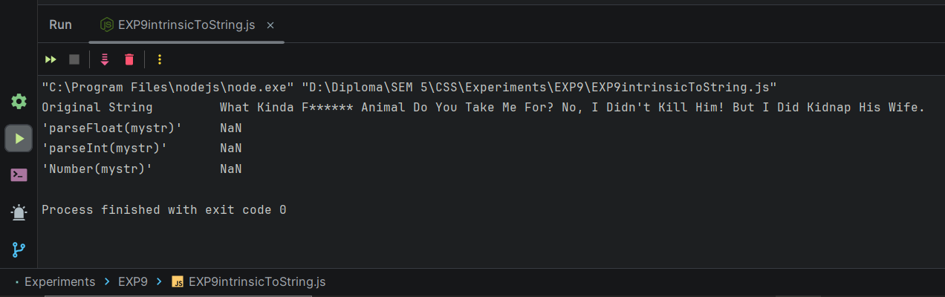

**2) Write a program to perform various Intrinsic functions.**

**CODE:**

**let myArray = ["Lester Crest","Trevor Philips","Franklin Clinton","Micheal D Souza"];  
  
console.log("\n\tArray related Intrinsic Functions:\n");  
  
console.log("\tOriginal Array:");   
console.log("\t["+myArray+"]");  
myArray.pop();  
console.log("\n\tAfter Popping:");   
console.log("\t["+myArray+"]");  
console.log("\n\tAfter Shifting:");   
myArray.shift();  
console.log("\t["+myArray+"]");  
console.log("\n\tString related Intrinsic Functions:\n");  
let myStr = "Lamar Davis";  
console.log("\t'Original String'\t" + myStr);   
console.log("\t'parseFloat(mystr)'\t"+parseFloat(myStr));  
console.log("\t'parseInt(mystr)'\t"+parseInt(myStr));  
console.log("\t'Number(mystr)'\t\t"+Number(myStr));**

**OUTPUT:**

